**ROBOL FUNCTIONAL REQUIREMENTS**

**Hardware required for BOT circuit:**

1. **ARDUNIO CONTROLLER:** Ardunio consists of both a physical programmable circuit board (often referred to as a [microcontroller](http://en.wikipedia.org/wiki/Microcontroller)) and a piece of [software](http://arduino.cc/en/Main/Software), or IDE (Integrated Development Environment) that runs on your computer, used to write and upload computer code to the physical board. The Ardunio does not need a separate piece of hardware in order to load new code onto the board -- you can simply use a USB cable. Additionally, the Ardunio IDE uses a simplified version of C++, making it easier to learn to program.

 Ardunio Uno features 14 digital input/output pins (six of which can be used as PWM outputs), six analog inputs, and a 16MHz quartz crystal. Uno also includes a USB connection, a power jack, an In-Circuit Serial Programming (ICSP) header, and a reset button

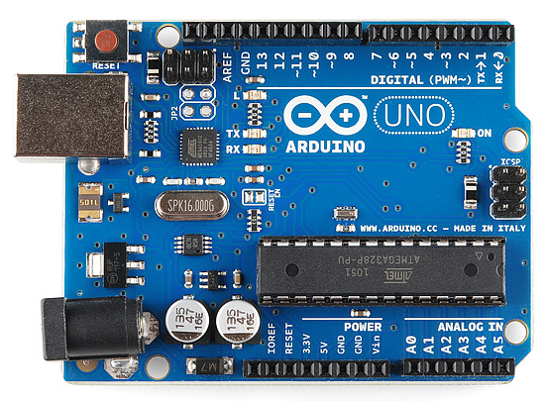

**Ardunio controller board**

1. **MOTOR DRIVING CIRCUIT:** Motor Driver circuits are current amplifiers. They act as a bridge between the controller and the motor in a motor drive. Motor drivers are made up of discrete components that are integrated inside an integrated circuit (IC).

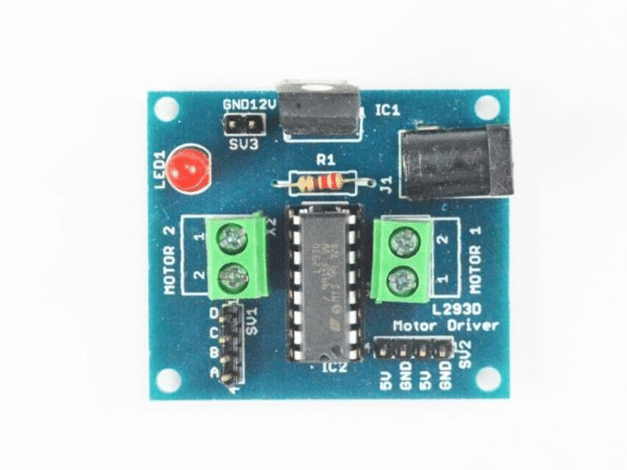

**Motor driving circuit**

1. **LDO voltage Regulators**: An LDO (low dropout) regulator is a linear regulator that can operate at a very low potential difference between the input and output voltage. A low-dropout regulator's (LDO) nature is to regulate a voltage by turning excess power into heat.

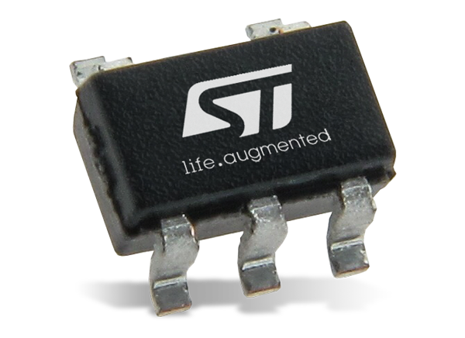

**LDO VOLTAGE REGULATOR**

1. **TOUCH SENSOR:** A touch sensor is a type of equipment that captures and records physical touch or embrace on a device and/or object. Touch sensors work similar to a switch. When they are subjected to touch, pressure or force they get activated and act as a closed switch. When the pressure or contact is removed they act as an open switch.. These are simple to design, low cost and are produced in large scale

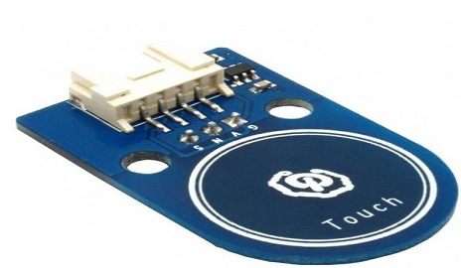

**TOUCH SENSOR**

1. **RAIN SENSOR:** A rain sensor is one kind of switching device which is used to detect the rainfall. It works like [a switch](https://www.elprocus.com/sound-activated-switch/) and the working principle of this sensor is, whenever there is rain, the switch will be normally closed. The rain sensors are based on Total Internal Reflection.

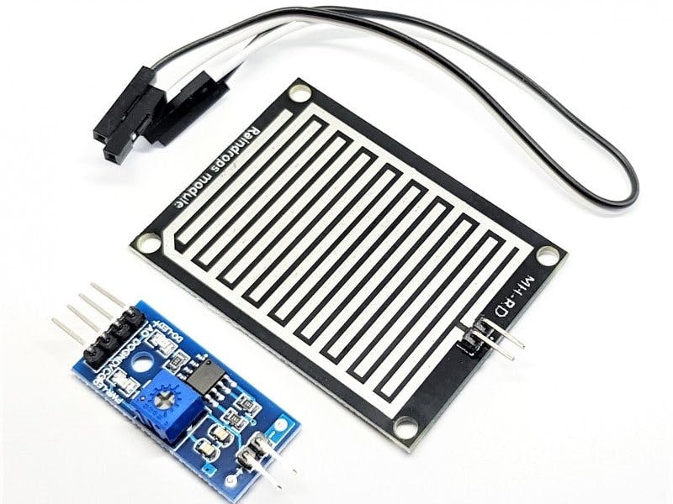

**RAIN SENSOR**

1. **SOUND DETECT SENSOR:** A sound sensor is defined as a module that detects sound waves through its intensity and converting it to electrical signals. This sensor employs a microphone to provide input to buffer, peak detector and an amplifier. This sensor notices a sound, & processes an o/p voltage signal to a microcontroller. After that, it executes required processing.

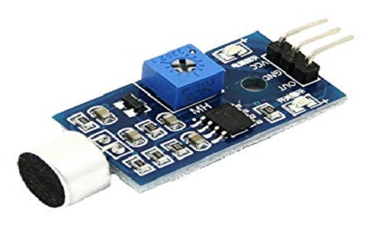

**SOUND DETECTION SENSOR**

1. **OBJECT DETECT SENSOR**: IR sensor is an electronic device that emits the light in order to sense some object of the surroundings. An IR sensor can measure the heat of an object as well as detects the motion. Infrared sensors emit infrared light and once this light hits an object, it is reflected back to the sensor. Depending on the strength of the reflected light, the sensor will know how far or close an object is. The stronger the reflected signal, the closer the object. The weaker the signal, the farther the object is.

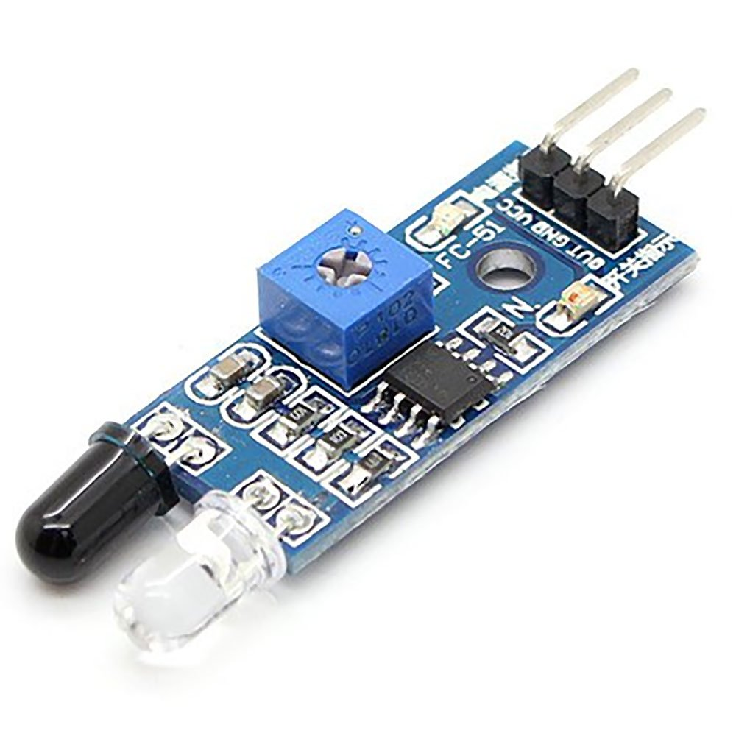

**OBJECT DETECT SENSOR**

1. **IR RECIEVER CIRCUIT:** IR Receiver Circuit is used to receive infrared signal from infrared transmission. Typical IC used is LM 358.IR Receiver Circuit is used to receive infrared signal from infrared transmission. Typical IC used is LM 358. It can receive infrared signal within 10 m. It operating voltage is 3.3v – 5v. The output signal compatible with TTL level 5v. A remote control patterns a flash of invisible light which is turned into an instruction and is received by the receiver module.

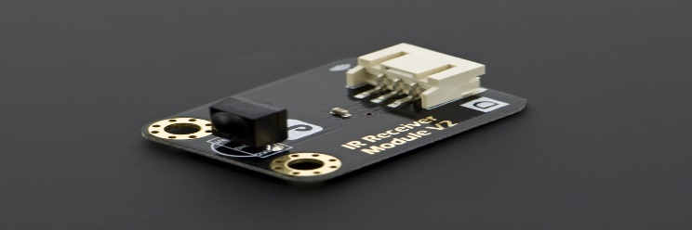

**IR RECIEVER CIRCUIT**

1. **LDR SENSOR:** A photo resistor or light-dependent resistor (LDR) or photocell is a light-controlled variable resistor. A Light Dependent Resistor (LDR) works on the principle that its resistance. The resistance of a photo resistor decreases with increasing incident light intensity In other words, it exhibits photoconductivity.

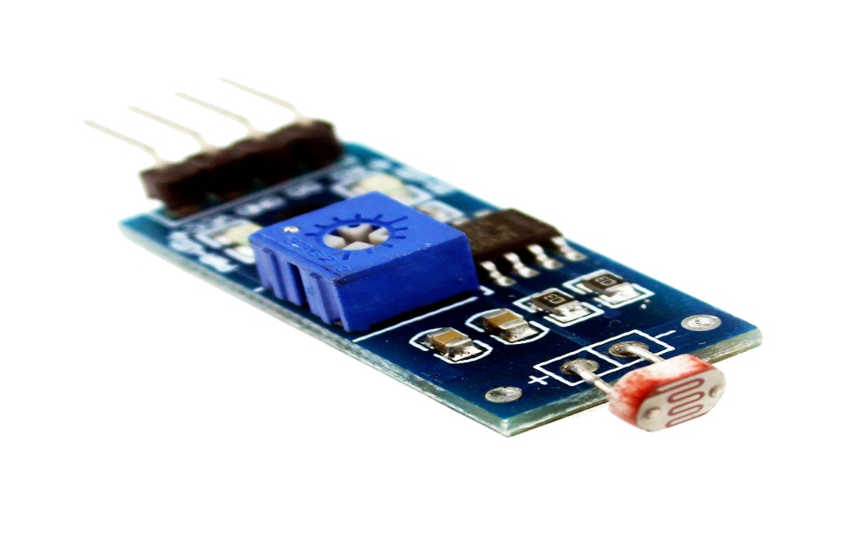

**LDR SENSOR**

1. **RF RECIEVER:** An RF receiver module receives the modulated RF signal, and [demodulates](https://en.wikipedia.org/wiki/Demodulation) it. There are two types of RF receiver modules: [super heterodyne receivers](https://en.wikipedia.org/wiki/Superheterodyne_receiver) and super regenerative. RF system communication use 433MHz frequency.

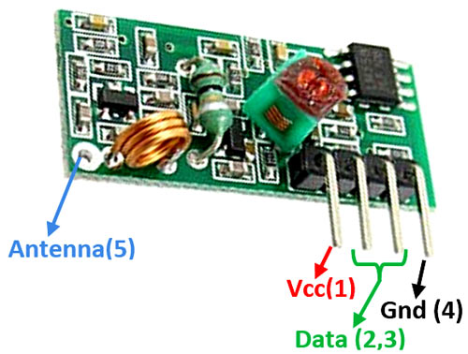

**RF RECIEVER**

**11) EYE LED:** A Light Emitting Diode (LED) is a semiconductor device, which can emit light when an electric current passes through it. To do this, holes from p-type semiconductors recombine with electrons from n-type semiconductors to produce light. This LED is used as eyes for the BOT.

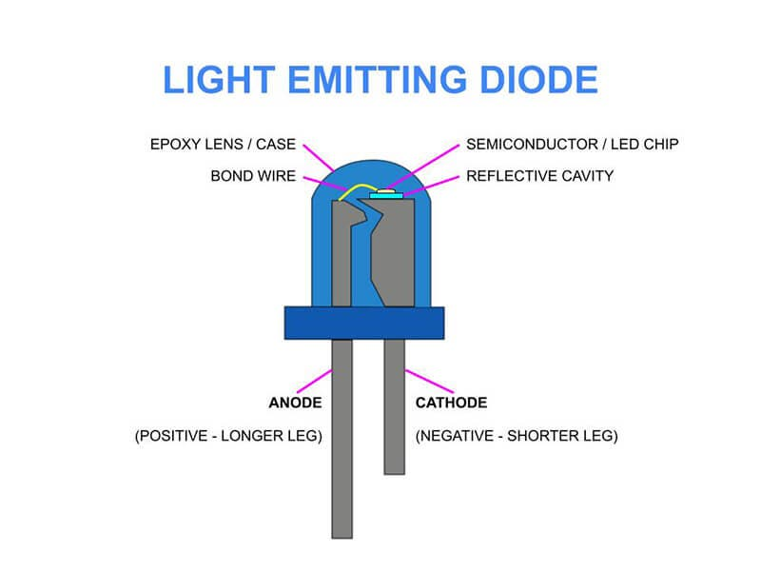

1. **DEBUGGING LED:** Debugging is the process of finding and resolving defects or problems within a robot that prevents correct operation of robot or a system. To indicate the bug or issue in the robot, LED starts indication until the bug solved**.**
2. **BUZZER:** An audio signaling device like a beeper or buzzer may be electromechanical or [piezoelectric](https://www.elprocus.com/what-is-a-piezoelectric-material-working/) or mechanical type. The main function of this is to convert the signal from audio to sound. Generally, it is powered through DC voltage and used in timers, alarm devices, printers, alarms, computers, etc. Based on the various designs, it can generate different sounds like alarm, music, bell & siren.

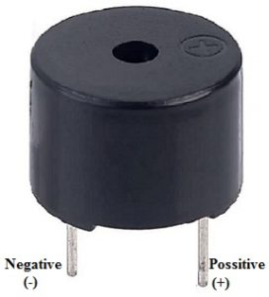

**BUZZER**

**Hardware required for SLATE circuit:**

1. **ARDUNIO MEGA 2560:** The **Ardunio Mega 2560** is a microcontroller board based on the [ATmega2560](http://ww1.microchip.com/downloads/en/DeviceDoc/Atmel-2549-8-bit-AVR-Microcontroller-ATmega640-1280-1281-2560-2561_datasheet.pdf). It has 54 digital input/output pins (of which 15 can be used as PWM outputs), 16 analog inputs, 4 UARTs (hardware serial ports), a 16 MHz crystal oscillator, a USB connection, a power jack, an ICSP header, and a reset button. It contains everything needed to support the microcontroller; simply connect it to a computer with a USB cable or power it with a AC-to-DC adapter or battery to get started. The Mega 2560 board is compatible with most shields designed for the Uno and the former boards Duemilanove or Diecimila

. 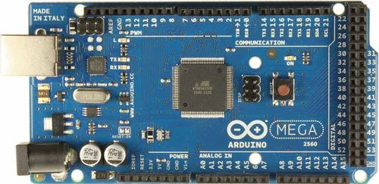

1. **RF TRANSMITTER:** An RF transmitter module is a small PCB sub assembly capable of transmitting a radio waves and modulating that wave to carry data. Transmitter modules are usually implemented alongside a microcontroller which will provide data to the module to be transmitted. RF transmitters are usually subject to regulatory requirements which dictate the maximum allowable transmitter power output, harmonics and band edge requirements.

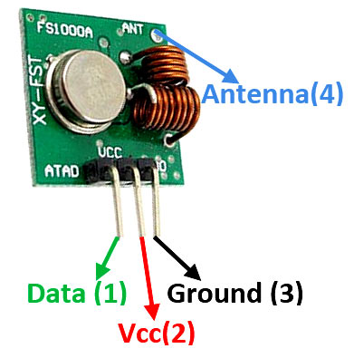

**RF TRANSMITTER**

1. **IR TRANSMITTER AND RECIEVER FOR SLIDER:** The sliding mechanical motion converts all command of the slate to the controller. These tokens are placed on slate in the order which you want the program to run then slide “The slider” on top of it from left hand side to the right which then sends the same information to the Arduino which does the compilation work and will then transmits this program using the 433Mhz RF module to the bot where it executes the same. Slider consists of two parts: IR transmitter array & IR receiver array. These two are arranged in such a way that both slide on the slate at the top and bottom at the same time. When scanning has started the transmitter sends the IR rays and receiver receives the IR from the hole arrangement made on the tokens And then based on the matrix of data received the slider, the controller coverts this data into the pre programmed keywords which is then sent to the RF transmitter which then send it to the bot.

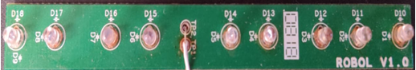

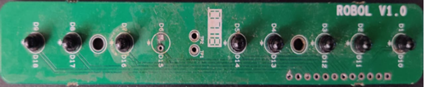

**IR TRANSMITTER**

1. **RGB LED(ERROR LED):** When it is lit, the system-error LED indicates that a system-board error has occurred. When sliding happen, the controller keeps checking for an error in every matrix. If there is a bug, error led start blinking.
2. **SWITCH BOARD**: Switch board is one of the command board of the slate system. Each switch consists of predefined command ensured in controller of the robot. It consists of four pushbutton switches. They are rated at 1A, 120 V.

**COINS**: Each coin has a command that is placed in a correct manner to do a task.

